STOCK PRICE PREDICTION USING MACHINE LEARNING

Abstract
This project focuses on predicting stock prices for the top five Indian banks listed in the Nifty 50 index. Utilizing data from the past five years, we aim to forecast future stock prices to support investment decisions and market analysis. The selected banks include SBI, HDFC, Axis, ICICI, and IndusInd Bank. By analyzing historical stock data, the project intends to provide valuable insights into market trends and stock performance.
The workflow begins with collecting relevant data and proceeds through various analytical stages to ensure robust model development and testing. The goal is to create reliable predictions of stock closing prices for the first half of 2024, comparing these predictions against actual market data to validate model accuracy. This project aims to enhance understanding of stock market behaviors, ultimately aiding investors, analysts, and financial professionals in making informed decisions.
By focusing on these prominent banks, the project highlights their significance in the Indian financial market and provides a framework for future predictive analyses. The outcomes are expected to contribute meaningfully to the field of financial forecasting, showcasing the potential of advanced data analysis techniques in the finance sector.
2.Background
For a considerable amount of time, scholars, financial analysts, and investors have been deeply interested in stock market prediction. Economic forecasting, risk management, and investment strategies can all be greatly impacted by accurate stock price forecasting. With the development of technology and the accessibility of enormous volumes of financial data, a number of advanced methods have been created to make more accurate stock price predictions.
The top 50 firms listed on the National Stock Exchange (NSE) make up the Nifty 50 index, which serves as a gauge of the Indian economy. The banking industry is one of the most important of them, with some of the most significant banks being State Bank of India (SBI), HDFC Bank, Axis Bank, ICICI Bank, and IndusInd Bank. Because of their importance to the financial system, stakeholders keep a careful eye on these banks' stock performance.
In recent years, the integration of data science and machine learning into financial analysis has opened new avenues for predicting stock prices. By leveraging historical data and advanced modeling techniques, it is possible to uncover patterns and trends that traditional analysis might miss. This project aims to harness these capabilities to predict the stock prices of the leading Indian banks, providing valuable insights and aiding in more informed decision-making for market participants.
3.Objectives
Developing a dependable and precise forecasting model to anticipate the stock prices of the top five Indian banks featured in the Nifty 50 index—SBI, HDFC Bank, Axis Bank, ICICI Bank, and IndusInd Bank—is the main goal of this project. By analyzing historical stock data from the past five years, the project aims to identify patterns and trends that can inform future price movements. A key goal is to compare actual stock prices with predicted values for the first half of 2024 to validate the models' accuracy. This comparison will highlight the effectiveness of various predictive techniques and help refine them for better performance. The project seeks to enhance the understanding of stock price dynamics, providing stakeholders, including investors and financial analysts, with actionable insights. Furthermore, the project aims to contribute to the broader field of financial forecasting by demonstrating the practical application of advanced data analysis methods in predicting stock market behavior. Ultimately, the objective is to support informed decision-making in the financial market, reducing risks and optimizing investment strategies through precise and timely predictions.
4.Scope of Work
This project focuses on developing a robust and accurate model to predict the stock prices of the top five Indian banks listed in the Nifty 50 index. Accurate predictions are crucial for investors and analysts in the financial market. The scope includes the following key areas:
- Data Collection:
Using the Yahoo Finance API, get historical stock price information for SBI, HDFC Bank, Axis Bank, ICICI Bank, and IndusInd Bank over the last five years.
- Exploratory Data Analysis (EDA):
Perform detailed EDA to uncover trends, patterns, and anomalies in the stock price data, providing a solid foundation for the subsequent steps.
- Feature Engineering:
Develop and select relevant features to enhance the predictive power of the models, ensuring the data is appropriately prepared for analysis.
- Data Splitting:
To provide reliable model validation, split the dataset into training and testing sets. For testing, use data from the first half of 2024.
- Model Development:
Implement various predictive models, including LSTM, stacked LSTM, GRU, , , and RNN, to encompass both traditional and advanced machine learning techniques.
- Modeling Training and Evaluation:
Use past data to train the models and evaluate their efficacy on the most recent data. For the first half of 2024, compare projected and actual stock prices.
- Model Evaluation:
Evaluate the model's performance by applying suitable metrics to ascertain the precision and dependability of the forecasts, hence pinpointing the optimal model.
- Prediction and Reporting:
Generate future stock price predictions based on the best-performing model and compile a comprehensive report detailinsg the methodology, analysis, findings, and actionable insights for stakeholders.

3.4 Existing system

The existing systems for stock price forecasting will rely on conventional statistical models such as the simple machine learning algorithms such as Random Forest and Support Vector Machines (SVM). These methods have been widely used due to their straightforward implementation and interpretability. However, they often struggle In order to effectively capture intricate and non-linear patterns, stock price data has long-term dependencies.

Disadvantages:
Inadequate for Long-Term Dependencies: Simple machine learning models do not handle long-term dependencies well, leading to less accurate predictions over extended periods.
Overfitting Risks: Ensemble methods such as Random Forest may overfit decreasing their capacity to extrapolate to unobserved data from the training set.
Parameter Sensitivity: Models like SVM require careful tuning of parameters, which can be time-consuming and complex.
Static Nature: Existing systems often lack adaptability to changing market conditions, limiting their effectiveness in dynamic financial environments.

3.5 Proposed System

The proposed framework improves stock cost guaging by coordinating high level profound learning models — Long Momentary Memory (LSTM) organizations, Gated Repetitive Units (GRU), Stacked LSTM, and Stacked GRU — with customary strategies like Irregular Timberland, Backing Vector Machines (SVM), and AutoRegressive Incorporated Moving Normal (ARIMA).

Advantages
Enhanced Temporal Pattern Recognition: LSTM and GRU networks excel in identifying long-term relationships and complex temporal patterns in stock price data, addressing limitations of traditional methods that often struggle with non-linearity and sequence learning.
Hierarchical Feature Learning: Stacked LSTM and Stacked GRU architectures allow for multi-layered representation learning, enabling the models to understand higher-level abstractions and intricate patterns in stock prices.
Improved Forecast Accuracy: By combining deep learning models with ensemble techniques and ARIMA, the proposed system integrates diverse forecasting strategies, leading to more accurate and reliable predictions compared to single-method approaches.
Adaptability to Market Dynamics: Advanced models can adapt to varying market conditions and evolving trends, offering improved performance in dynamic financial environments where traditional models may fall short.
Reduced Overfitting: The use of complex architectures and hybrid models lessens the gamble of overfitting by giving a more comprehensive and flexible approach to capturing diverse data patterns, enhancing generalization to unseen data.

Project flow

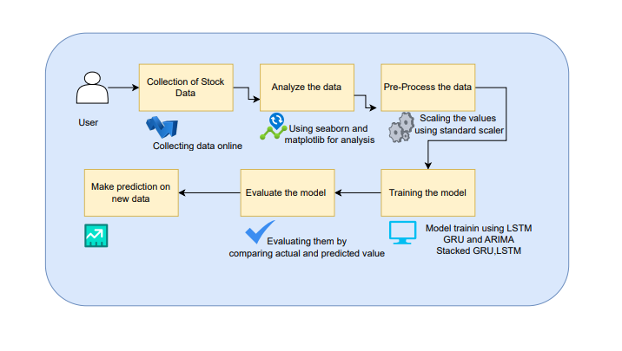

SOFTWARE HARDWARE REQUIREMENTS
H/W CONFIGURATION:
Processor - I3/Intel Processor
Hard Disk - 160GB
Key Board - Standard Windows Keyboard
Mouse - Two or Three Button Mouse
Monitor - SVGA
RAM - 8GB
S/W CONFIGURATION:
- Operating System : Windows 7/8/10
- Server side Script : HTML, CSS, Bootstrap & JS
- Programming Language : Python
- Libraries : Flask, Pandas, MySQL. Connector, Scikit-Learn, pytorch
- IDE/Workbench : VS Code
- Technology : Python 3.8+
Server Deployment : Xampp Server

